**• Explain how to render multiple components**

**Ans.** a) **Wrapping in a div**

return (

<div>…………...</div>

);

b) **Using React fragments**

return (

<>……………..</ >

);

**• Define list component**

**Ans.** Itis a component that renders a list of elements, using .map().

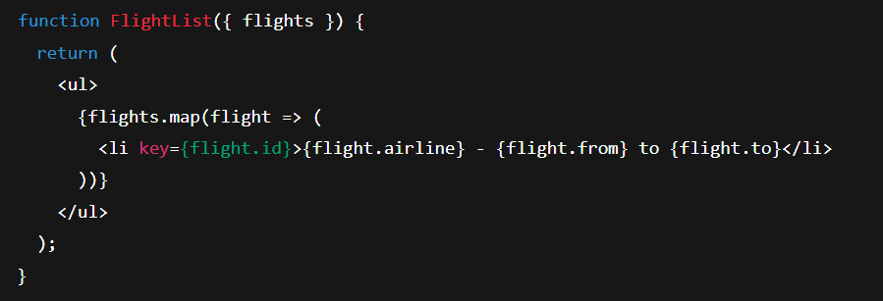

**• Explain about keys in React applications**

**Ans.** Keys are unique identifiers for elements in a list. It helps to update, reorder or remove items.



**• Explain how to extract components with keys**

**Ans.** Pass the key to the component instance, not inside it.

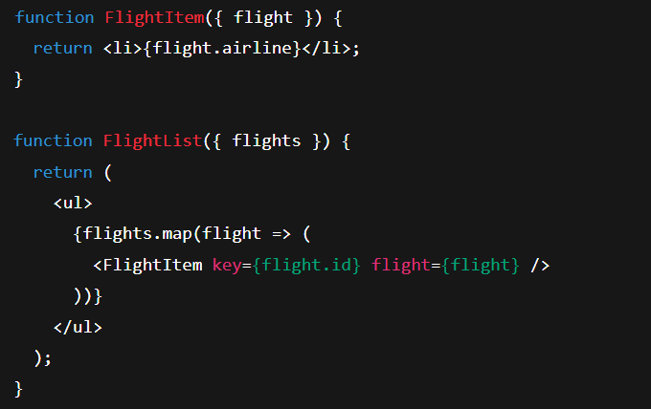

**• Explain React Map, map() function**

**Ans.** The map() function is used to iterate over arrays and return new JSX elements for each item.

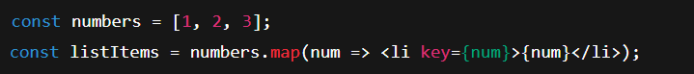

It returns

**[<li>1</li>, <li>2<li/>, <li>3</li>]**